INCLUDE Irvine32.inc

.data

coal word 1234h,5678h,3456h

val word 12h

result byte ?

a byte 16

.code

main PROC

mov eax,0

mov ebx,0

mov edx,0

mov bl,a

mov al,BYTE PTR coal[4]

div bl

mov ah,0

call WriteHex

mov dl,BYTE PTR val

add al,dl

Call dumpregs

mov eax,0

mov ebx,0

mov bl,a

mov al,BYTE PTR coal[2]

div bl

mov ah,0

call WriteHex

mov dl,BYTE PTR val

add al,dl

Call dumpregs

mov eax,0

mov ebx,0

mov bl,a

mov al,BYTE PTR coal[0]

div bl

mov ah,0

call WriteHex

mov dl,BYTE PTR val

add al,dl

Call dumpregs

exit

main ENDP

END main

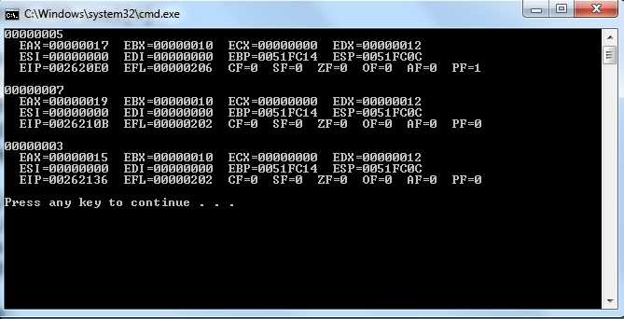

-----------------3---------------------

INCLUDE Irvine32.inc

.data

arr1 word 100,200,300,400,500

arr2 BYTE 2,4,6,8,10

arr3 BYTE 5 DUP(?)

a BYTE 0

.code

main PROC

mov eax,0

mov ebx,0

mov ecx,5

mov si,0

L1:

mov bl,arr2[si]

mov al,BYTE ptr arr1[si]

div bl

mov arr3[si],bl

call writedec

call crlf

inc si

loop L1

exit

main ENDP

END main

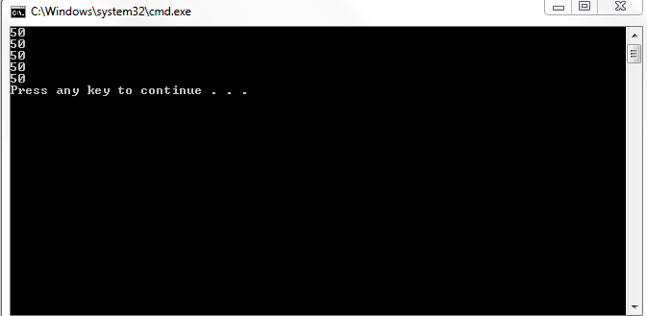

------------------------5-------------------

INCLUDE Irvine32.inc

.data

s byte "This is fast nuces",0

a byte 'x'

p1 byte 5

p2 byte 15

b byte 2

.code

main PROC

L1:

mov edx,offset s

mov ecx,sizeof s

call writestring

call crlf

mov al,a

call writechar

call crlf

mov eax,0

mov al,b

add al,4

call writedec

mov b,al

call crlf

add p1,1

movzx eax,p1

movzx ebx,p2

cmp eax,ebx

jle L1

jmp L2

L2:

exit

main ENDP

END main

---------4-------------------

INCLUDE Irvine32.inc

.data

num dword ?

.code

main PROC

mov eax,num

call readdec

call writedec

call crlf

mov ecx,num

mov ebx,0

mov ebx,1

L1:

mov eax,num

mul ebx

call writedec

inc ebx

loop l1

exit

main ENDP

END main

-----------------------------2-------------------------

INCLUDE Irvine32.inc

.data

a byte ?

b byte ?

c byte ?

x byte 2

.code

main PROC

mov al,a

call readdec

mov al,b

call readdec

mov al,c

call readdec

mov bl,b

neg b

mov al,a

mul x

exit

main ENDP

END main